C/C++ STUDENT 'CLASS' LAB REPORT

1) Enter your name, student ID, platform (Mac or PC) and date
Name and Student ID: Brian Quintero
Class: CIS054 C/C++ Programming
Platform (Mac or PC): Pc
Date: 5/9/17

DESCRIPTION:
Modify the Student 'class' files as follows:
1) Add a Major field to the Student class definition. Update the student.h and student.cpp files to include the additional field. Be sure to include a get and set method for the Major field.
2) Add several majors such as CIS, Math, English, etc. to the students in the array of students located in the main program.
3) When displaying the list of student ID numbers and student names, also display their major. For C++ use the setw( ) function to set the widths of each column so that the columns line up on the screen when displayed. For the C-language, set the parameters for %s in the format string.
4) Change some of the ID numbers and GPAs to illegal values. Have the program detect and display an error message when the illegal values are present.

EXTRA CREDIT: 3 points – must be submitted at the same time as the original lab report
Display a header at the top of the table similar to:
ID # NAME MAJOR
============================================

LAB REPORT:
2) Determine the Inputs, Processing and Outputs before creating the program
INPUTS | PROCESSING | OUTPUTS
{  if (isupper(n[0])) // 1st character of name must be A-Z  name = n;  else  name = "--Bad name entered";  }  string Student::getName()  {  return name;  }  void Student::setIdNumber(int id)  {  if (id>1 && id<100000) // must be from 0 to 100000  IdNumber = id;  else  IdNumber = 0; // indicate an illegal selection  }  int Student::getIdNumber()  {  return IdNumber;  }  void Student::setGpa(double g)  {  if (g >= 0.0 && g <= 4.0) // gpa must be from 0.0 to 4.0  gpa = g;  else  gpa = 0;  }  double Student::getGpa()  {  return gpa;  } | for (int i = 0; i<NumberOfStudents; i++)  cout << " " << CIS054[i].getIdNumber() << " " << CIS054[i].getName() << endl;  cout << endl; // blank line after displaying the student names  // compute the average gpa of all the students  double total = 0;  for (int i = 0; i<NumberOfStudents; i++)  total += CIS054[i].getGpa();  double average = total / NumberOfStudents;  cout << " " << "The average GPA of all the students is " << average << endl << endl;  return 0;  } | Student CIS054[] = {  Student("Joe Williams", 44536, 3.4),  Student("Sally Washington", 55458, 3.7),  Student("Fred MacIntosh", 66587, 2.9),  Student("Jose De La Cruz", 67892, 3.5),  Student("777 Dan McElroy", 77777, 4.0),  Student("Thinh Nguyen", 73657, 3.6)  };

3) Fill in the EXPECTED & ACTUAL RESULTS
TEST DATA VALUES  Provide different examples including an illegal Student ID | EXPECTED RESULT  Computed values before the program is run | ACTUAL RESULT  Fill in the output displayed  by the program
 | 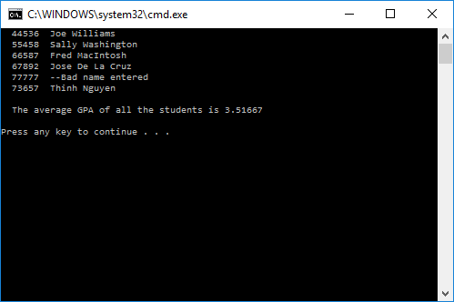
DISCUSSION:
4) Complete the DISCUSSION section. It does not need to be long, but it needs to be complete.
4a) What did you do to develop the program? ("Followed the Directions" is not a complete description)

I had to figure out how to set the header file as the first program, and then I had to figure out how to make the .cpp files available for the program to run.

4b) What problems did you have and how did you overcome the problems?
I didn’t know how to set the .cpp files at first but in the end it was easier than I expected. So not much trouble In this one.

PROGRAM OUTPUT:
5) Show a screen of the program execution that includes an illegal selection for name.
For extra credit, display a header row and a ==== separator line.
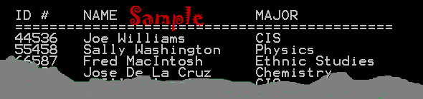
Refer to previous lab assignments for instructions on how to capture a screen or portions of a screen for either the PC or a Mac

PROGRAM LISTING:
6) Copy and paste the code that YOU typed to make the program work. Your program should include a comment block at the top that shows the name of the program, date, version and your name.

#pragma once
// Student.h
#include <string>
using namespace std;

class Student
{
private:
string name;
int IdNumber;
double gpa;
public:
// constructors
Student(); // default constructor
Student(string n, int id, double g);

//mutators and accessors
void setName(string n);
string getName();
void setIdNumber(int id);
int getIdNumber();
void setGpa(double g);
double getGpa();
};
// Student_Class.cpp : Defines the entry point for the console application.
//

#include "stdafx.h" // for some versions of Microsoft Visual C++
#include <iostream>
#include "Student.h"
using namespace std;

// define an array of students
Student CIS054[] = {
Student("Joe Williams", 44536, 3.4),
Student("Sally Washington", 55458, 3.7),
Student("Fred MacIntosh", 66587, 2.9),
Student("Jose De La Cruz", 67892, 3.5),
Student("777 Dan McElroy", 77777, 4.0),
Student("Thinh Nguyen", 73657, 3.6)
};

int main(int argc, char* argv[])
{
int NumberOfStudents = sizeof(CIS054) / sizeof(Student);

// Display the header line
// List all the students in the course
for (int i = 0; i<NumberOfStudents; i++)
cout << " " << CIS054[i].getIdNumber() << " " << CIS054[i].getName() << endl;
cout << endl; // blank line after displaying the student names

// compute the average gpa of all the students
double total = 0;
for (int i = 0; i<NumberOfStudents; i++)
total += CIS054[i].getGpa();
double average = total / NumberOfStudents;
cout << " " << "The average GPA of all the students is " << average << endl << endl;
return 0;
}

#include "stdafx.h" // only for Microsoft Visual Studio C++ programs
#include "Student.h"
#include <cctype> // used by isalpha (test for a character)
using namespace std;

// default Student constructor
Student::Student()
{
name = ""; // set name to an empty string
IdNumber = 0;
gpa = 0.0;
}
// Fully qualified Student constructor
Student::Student(string n, int id, double g)
{
setName(n); // use setName to validate data
setIdNumber(id); // use setIdNumber to validate data
setGpa(g); // use setGpa to validate data
}

//mutators and accessors
void Student::setName(string n)
{
if (isupper(n[0])) // 1st character of name must be A-Z
name = n;
else
name = "--Bad name entered";
}
string Student::getName()
{
return name;
}
void Student::setIdNumber(int id)
{
if (id>1 && id<100000) // must be from 0 to 100000
IdNumber = id;
else
IdNumber = 0; // indicate an illegal selection
}
int Student::getIdNumber()
{
return IdNumber;
}
void Student::setGpa(double g)
{
if (g >= 0.0 && g <= 4.0) // gpa must be from 0.0 to 4.0
gpa = g;
else
gpa = 0;
}
double Student::getGpa()
{
return gpa;

